**Music Lesson Plans for April 27th to May 1st, 2020 Grade 2**

**Rhythm Notes:**

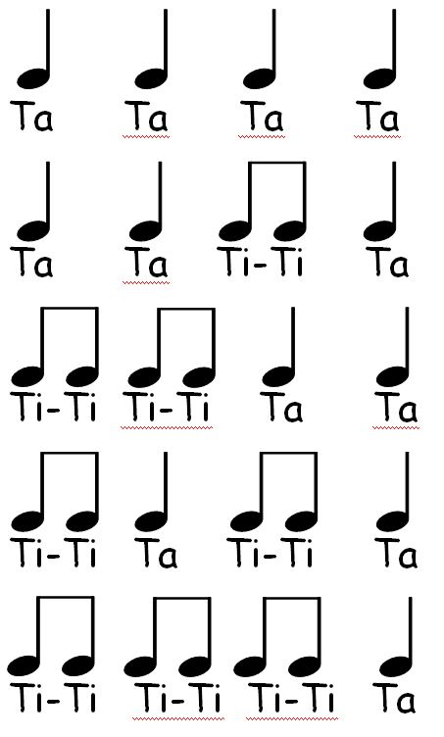

**How to find the note names on the staff:**

**In order to figure out the names of the notes, you have to answer the following questions…**

1. **Is the note on a line or a space?**
2. **If the note is on the line, you will use the EGBDF**

**If the note is on the space, you will use the FACE**

1. **You count from the bottom line or space to where the note is on the line or space.**

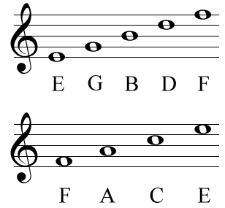

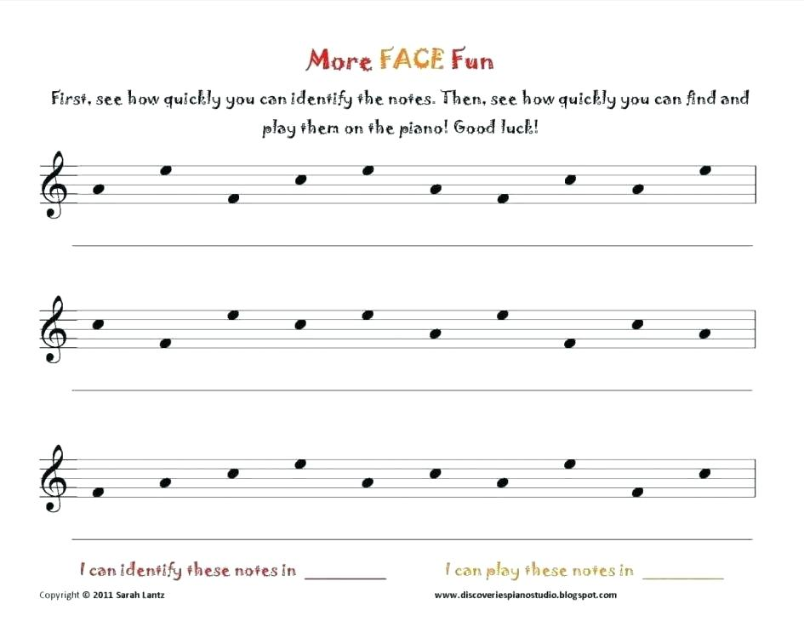

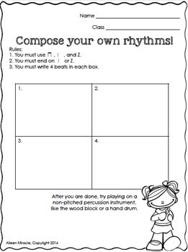

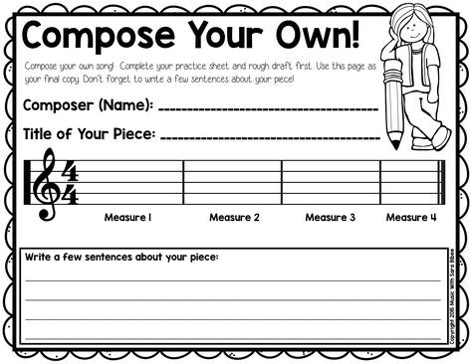

**Rhythm Games:**

**Materials:**

**One Piece of white paper**

**Crayons**

**Directions:**

**Fold a blank piece of paper four times.**

**Have the students open the folded piece of paper.**

**Tell the students to write the rhythm the teacher states to the class.**

